Software Requirement Specification
For
LLM-Prop: Crystal Structure Property Prediction System
Version 1.0 approved
Prepared by:
Shaurya Shekhar 24bd1a661k
S.S.Srivatsa 25bd5a6604
Avani Jahagirdar 24bd1a6605
Keshav Memorial Institute of Technology
06/08/2026

Revision History
Name | Date | Reason for changes | Version
Project Team | 11-09-2020 | SRS creation (Introduction) | 1.0
Project Team | 18-09-2020 | SRS updation | 2.0
Project Team | 25-09-2020 | Overall Description and Interface Requirements added | 3.0
Project Team | 02-10-2020 | System Features and Nonfunctional Requirements added | 4.0
Project Team | 09-10-2020 | Final review and approval | 5.0

Table of Contents
Revision History 1
Table of Contents 1
1. Introduction 1
1.1 Purpose 1
1.2 Document Conventions 1
1.3 Intended Audience and Reading Suggestions 1
1.4 Product Scope 1
1.5 References 1
2. Overall Description 1
2.1 Product Perspective 1
2.2 Product Functions 1
2.3 User Classes and Characteristics 1
2.4 Operating Environment 1
2.5 Design and Implementation Constraints 1
2.6 User Documentation 1
2.7 Assumptions and Dependencies 1
3. External Interface Requirements 1
3.1 User Interfaces 1
3.2 Hardware Interfaces 1
3.3 Software Interfaces 1
3.4 Communications Interfaces 1
4. System Features 1
4.1 Crystal Structure Text Processing 1
4.1.1 Description and Priority 1
4.1.2 Stimulus / Response Sequence 1
4.1.3 Functional Requirements 1
4.2 Property Prediction Model 1
4.2.1 Description and Priority 1
4.2.2 Stimulus / Response Sequence 1
4.2.3 Functional Requirements 1
5. Other Nonfunctional Requirements 1
5.1 Performance Requirements 1
5.2 Safety Requirements 1
5.3 Security Requirements 1
5.4 Software Quality Attributes 1
5.5 Business Rules 1
6. Other Requirements 1
Appendix A: Glossary 1
Appendix B: Analysis Models 1
Appendix C: To Be Determined List 1
Software Development Life Cycle (SDLC) 1
What is SDLC? 1
Stages of the SDLC applied to LLM-Prop 1
Stage 1: Planning and Requirement Analysis 1
Stage 2: Defining Requirements 1
Stage 3: Designing the Product Architecture 1
Stage 4: Building or Developing the Product 1
Stage 5: Testing the Product 1
Stage 6: Deployment and Maintenance 1
An Overview of UML 1
Diagrams Used in This Document 1
Use Case Diagram 1
Sequence Diagram 1
Collaboration Diagram 1
Class Diagram 1
State Chart Diagram 1
Activity Diagram 1
Package Diagram 1
Component Diagram 1
Deployment Diagram 1

1. Introduction

1.1 Purpose
This document presents the Software Requirements Specification (SRS) for LLM-Prop: Crystal Structure Property Prediction System, Version 1.0. This SRS defines the complete set of functional and nonfunctional requirements for the full standalone system and describes the behavior, constraints, and interfaces of the software.
The purpose of this project is to develop an end-to-end deep learning system that predicts multiple material properties of crystalline materials from natural language descriptions of crystal structures. The descriptions are generated automatically from Crystallographic Information Files (CIF) using Robocrystallographer.
This document serves as a reference for developers, evaluators, and stakeholders to understand system functionality, scope, and expected performance.

1.2 Document Conventions
The following conventions are used throughout this document:
- Section headings are used to organize requirements into logical categories.
- Functional requirements are identified using the format REQ-X, where X is a unique number.
- All requirements are stated using the keyword “shall” to indicate mandatory behavior.
- Technical terms such as CIF, Transformer, T5, and MAE follow standard conventions used in materials informatics and machine learning.
- Numerical values are expressed using standard scientific units.
- Priority levels for system features are categorized as High, Medium, or Low.
- Each requirement is independent and does not inherit priority unless explicitly specified.

1.3 Intended Audience and Reading Suggestions
This document is intended for the following audience:
- Developers – to understand system architecture, components, and implementation requirements.
- Project Evaluators / Supervisors – to review system design and requirement completeness.
- Machine Learning Engineers – to understand model training, preprocessing, and prediction workflow.
- Researchers in Materials Science – to understand how crystal structure descriptions are used to predict material properties.
This SRS is organized into multiple sections. Section 1 provides an introduction and overview of the document. Section 2 describes the overall system, including its functions, users, and environment. Section 3 defines external interface requirements. Section 4 details the system features and functional requirements. Section 5 specifies nonfunctional requirements. Section 6 includes additional requirements.
Suggested reading order:
- 1. Introduction
- 2. Overall Description
- 3. External Interface Requirements
- 4. System Features
- 5. Other Nonfunctional Requirements

1.4 Product Scope
LLM-Prop is a machine learning-based materials informatics system designed to predict physical and electronic properties of crystalline materials from natural language descriptions of crystal structures.
The system converts crystallographic data from CIF files into human-readable text using Robocrystallographer and processes this text using transformer-based deep learning models. These models extract structural and semantic information to predict multiple material properties.
The key objectives of the system include:
- Converting CIF files into natural language descriptions
- Preprocessing and preparing text data for model training
- Training transformer-based models for understanding crystal structures
- Predicting multiple material properties such as band gap, formation energy, and energy per atom
- Providing a simple command-line interface for users to input descriptions and obtain predictions
The system aims to support faster materials discovery by reducing dependence on costly experimental methods and computational simulations.

1.5 References
- TextEdge Dataset – Materials science dataset used for training and evaluation of material property prediction models. Source: Online dataset repository.
- Robocrystallographer – Tool for converting CIF files into natural language crystal structure descriptions. Developed by the Materials Project. Source: https://materialsproject.org
- T5 (Text-to-Text Transfer Transformer) – Raffel, C., et al., Google Research, 2019. Source: https://arxiv.org/abs/1910.10683
- Materials Project Database – Jain, A., et al., 2013. A database of computed materials properties. Source: https://materialsproject.org
- HuggingFace Transformers Library – Wolf, T., et al., 2020. Source: https://huggingface.co
- PyTorch Deep Learning Framework – Paszke, A., et al., 2019. Source: https://pytorch.org

2. Overall Description

2.1 Product Perspective
LLM-Prop is a standalone machine learning system designed for predicting material properties from crystal structure descriptions. It is not a subsystem of a larger software product but a complete end-to-end system.
The system consists of multiple components organized in a pipeline:
- Dataset collection from materials databases
- CIF file processing
- Conversion of CIF files into natural language descriptions using Robocrystallographer
- Text preprocessing and tokenization
- Transformer-based model training
- Property prediction using regression layers
- Command-line interface for user interaction
The system integrates materials science data processing tools with deep learning frameworks such as PyTorch and HuggingFace Transformers. It interacts with external datasets and tools but operates independently as a complete application.

2.2 Product Functions
The major functions of the system include:
- Loading crystallographic datasets from external sources
- Converting CIF files into natural language descriptions using Robocrystallographer
- Preprocessing and cleaning text data for model training
- Splitting datasets into training, validation, and test sets
- Tokenizing text input using pretrained transformer tokenizers
- Fine-tuning pretrained transformer models for property prediction
- Predicting multiple material properties such as band gap, formation energy, and energy per atom
- Evaluating model performance using metrics such as Mean Absolute Error (MAE)
- Providing a command-line interface (CLI) for user interaction and predictions

2.3 User Classes and Characteristics
The system is intended for the following user classes:
1. Student Researchers
- Use the system for academic projects and experimentation
- Have basic to moderate knowledge of Python and machine learning
- Require simple interfaces and clear outputs
2. Materials Science Researchers
- Use the system to predict properties of new or existing materials
- May provide crystal structure descriptions as input
- Have domain knowledge in materials science but limited programming expertise
3. Developers
- Responsible for system development, maintenance, and improvement
- Have strong knowledge of programming, machine learning, and software systems
- Work on model training, optimization, and system integration
Different requirements may apply to different user classes, with developers having the highest level of system access and control.

2.4 Operating Environment
The software will operate in the following environment:
Hardware:
- Standard computer system with CPU support
- Optional GPU for accelerated model training and inference
Operating System:
- Windows
- Linux
- macOS
Software Requirements:
- Python 3.9 or higher
- PyTorch deep learning framework
- HuggingFace Transformers library
- Pandas and NumPy libraries
- Robocrystallographer tool
- Access to Materials Project API
Execution Environment:
- Local machine setup
- Jupyter Notebook or Google Colab for experimentation and training

2.5 Design and Implementation Constraints
The system is subject to the following design and implementation constraints:
- The size of the transformer model is limited by available GPU memory and computational resources.
- Dataset size and accessibility may be restricted by external API limits such as the Materials Project API.
- Conversion of CIF files to natural language descriptions depends on the availability and correctness of the Robocrystallographer tool.
- Model training requires significant computational time and resources.
- The system must be implemented using Python and compatible machine learning libraries such as PyTorch and HuggingFace Transformers.
- Data preprocessing must ensure consistent formatting of input text for effective model training.
- The system must operate within standard operating systems without requiring specialized hardware beyond optional GPU support.

2.6 User Documentation
The system will include the following user documentation:
- Project Report – Describes the overall system design, methodology, and results.
- User Manual – Provides instructions for installing, running, and using the system.
- Command-Line Interface (CLI) Guide – Explains how to input crystal structure descriptions and interpret outputs.
- Installation Guide – Details required dependencies and setup steps.
- Model Training Documentation – Describes the process of training and evaluating the model.
- Code Repository Documentation – Includes code comments and usage instructions for developers.
All documentation will be provided in digital format.

2.7 Assumptions and Dependencies
Assumptions:
- CIF files used as input contain valid and correctly formatted crystallographic data.
- Robocrystallographer generates accurate and meaningful natural language descriptions from CIF files.
- The dataset used for training contains correct and reliable material property values.
- Users provide valid input descriptions when using the CLI interface.
Dependencies:
- Materials Project database for obtaining crystallographic datasets
- Robocrystallographer tool for converting CIF files to text descriptions
- HuggingFace Transformers library for pretrained models
- PyTorch framework for model training and inference
- External libraries such as Pandas and NumPy for data processing

3. External Interface Requirements

3.1 User Interfaces
The system provides a Command-Line Interface (CLI) for user interaction.
Interface Characteristics:
- Users can input crystal structure descriptions as plain text through the terminal.
- The system displays predicted material properties as output in a structured format.
Screen Layout:
- Input prompt: allows user to enter crystal structure description
- Output display: shows predicted properties such as band gap, formation energy, energy above hull, cell volume, and energy per atom
Standard Functions:
- Input validation to ensure non-empty and valid text input
- Display of error messages for invalid or missing input
- Clear labeling of predicted output values
Error Handling:
- If input is invalid or empty, the system shall display an appropriate error message
- If prediction fails, the system shall notify the user and terminate gracefully
Example Interaction:
Enter crystal description: “The structure consists of sodium atoms coordinated by chlorine atoms in a cubic lattice…”
Predicted Properties: Band Gap: 2.15 eV | Formation Energy: -3.2 eV | Energy Above Hull: 0.01 eV | Cell Volume: 85 Å³ | Energy per Atom: -5.3 eV

3.2 Hardware Interfaces
The system does not require any specialized hardware interfaces. It operates on standard computing hardware with the following characteristics:
- CPU-based execution supported on general-purpose computers
- Optional GPU support for accelerated model training and inference
- Memory requirements sufficient to handle dataset loading and model execution
There is no direct interaction with external hardware devices such as sensors, controllers, or embedded systems. All computations are performed within the host machine.

3.3 Software Interfaces
The system interfaces with the following software components:
Robocrystallographer
- Used to convert CIF files into natural language descriptions
- Input: CIF files
- Output: Text descriptions of crystal structures
Materials Project API
- Used to retrieve crystallographic datasets and material properties
- Provides structured data including CIF files and associated properties
HuggingFace Transformers Library
- Provides pretrained transformer models and tokenizers
- Used for text encoding and model fine-tuning
PyTorch Framework
- Used for model training, evaluation, and inference
- Handles neural network operations and optimization
Data Processing Libraries (Pandas, NumPy)
- Used for dataset handling, preprocessing, and numerical operations
Data exchange between these components is performed through standard file formats (e.g., CIF files, CSV datasets) and in-memory data structures.

3.4 Communications Interfaces
The system uses standard communication mechanisms for interacting with external services and data sources.
- Communication with external datasets (e.g., Materials Project API) is performed over the internet using HTTP/HTTPS protocols.
- Data exchanged with external services is typically in JSON format.
- Secure communication is ensured using HTTPS encryption when accessing external APIs.
- Data transfer depends on network availability and standard internet bandwidth; no real-time synchronization is required.
- The system operates in a request-response manner when fetching data from external sources.
No additional communication protocols such as FTP or socket-based communication are required.

4. System Features

4.1 Crystal Structure Text Processing

4.1.1 Description and Priority
This feature converts CIF crystal structure files into natural language descriptions using Robocrystallographer.
Priority: High

4.1.2 Stimulus / Response Sequence
Stimulus: User provides a CIF file or selects a dataset.
Response: The system processes the CIF file and generates a corresponding natural language description of the crystal structure.

4.1.3 Functional Requirements
REQ-1: The system shall load CIF files from the dataset.
REQ-2: The system shall convert CIF files into natural language descriptions.
REQ-3: The system shall store generated text descriptions for model training.
REQ-4: The system shall validate CIF file format before processing.
REQ-5: The system shall display an error message if the CIF file is invalid or corrupted.

4.2 Property Prediction Model

4.2.1 Description and Priority
This feature trains and utilizes a transformer-based model to predict material properties from crystal structure descriptions.
Priority: High

4.2.2 Stimulus / Response Sequence
Stimulus: A crystal structure description is provided by the user through the CLI or dataset.
Response: The system processes the input and outputs predicted material properties.

4.2.3 Functional Requirements
REQ-6: The system shall preprocess text descriptions for model input.
REQ-7: The system shall tokenize text using a pretrained tokenizer.
REQ-8: The system shall fine-tune a pretrained transformer encoder model.
REQ-9: The system shall predict multiple material properties.
REQ-10: The system shall evaluate predictions using Mean Absolute Error (MAE).
REQ-11: The system shall allow users to input descriptions through the CLI.
REQ-12: The system shall validate input text before processing.
REQ-13: The system shall display an error message for invalid or empty input.

5. Other Nonfunctional Requirements

5.1 Performance Requirements
- The system shall generate predictions within 2 seconds per input under normal operating conditions.
- The system shall support processing of datasets containing at least 10,000 samples without failure.
- Model training time shall be dependent on hardware but should complete within reasonable computational limits on a standard GPU-enabled system.
- The system shall efficiently utilize available CPU/GPU resources during training and inference.

5.2 Safety Requirements
- The system shall ensure that invalid or corrupted input data does not cause system crashes.
- The system shall validate all input files and user inputs before processing.
- The system shall handle errors gracefully and provide appropriate error messages to the user.
- The system shall prevent data loss during processing by maintaining intermediate results where necessary.
- The system shall avoid unintended modification of original dataset files.

5.3 Security Requirements
- The system shall ensure that dataset files and model files are protected from unauthorized modification.
- The system shall validate all external inputs to prevent malformed or harmful data processing.
- When accessing external APIs (e.g., Materials Project), the system shall use secure communication protocols such as HTTPS.
- Access to system files and datasets shall be restricted based on user permissions of the host environment.
- The system shall ensure data integrity during storage and processing.

5.4 Software Quality Attributes
Reliability
- The system shall produce consistent predictions for the same input under identical conditions.
Maintainability
- The system shall be modular, with clearly separated components for data processing, model training, and prediction.
- Code shall be well documented to support future updates and maintenance.
Scalability
- The system shall support expansion to larger datasets and more complex models in future versions.
Usability
- The system shall provide a simple and easy-to-use CLI interface.
- Output results shall be clearly formatted and understandable.
Portability
- The system shall run on multiple operating systems including Windows, Linux, and macOS.

5.5 Business Rules
- Only valid and properly formatted crystal structure descriptions shall be accepted as input.
- Users must follow the required input format when providing crystal descriptions through the CLI.
- Model training shall be performed only using approved datasets such as Materials Project or similar reliable sources.
- Predicted material properties are for research and academic purposes and should not be used for critical real-world decisions without validation.
- Developers are responsible for maintaining model accuracy and updating the system when new datasets or improvements are available.

6. Other Requirements
- The system shall support future extensions such as prediction of additional material properties.
- The system shall allow integration with web-based interfaces in future versions.
- The system shall support visualization of crystal structures as an optional enhancement.
- The system shall be designed to accommodate larger and more advanced transformer models.

Appendix A: Glossary
- CIF (Crystallographic Information File): A standard file format for representing crystal structure data.
- Transformer Model: A deep learning architecture used for processing sequential data such as text.
- MAE (Mean Absolute Error): A metric used to evaluate prediction accuracy.
- Band Gap: Energy difference between valence and conduction bands in a material.
- Formation Energy: Energy required to form a compound from its elements.

Appendix B: Analysis Models
- System workflow diagram (data collection → preprocessing → model training → prediction)
- Model architecture diagram (Transformer encoder + regression head)
- Data flow representation for CIF to text conversion and prediction pipeline

Appendix C: To Be Determined List
- TBD-1: Final dataset size and selection criteria
- TBD-2: Model architecture optimization details
- TBD-3: Hyperparameter tuning strategy
- TBD-4: Integration of web-based interface

Software Development Life Cycle (SDLC)
Software Development Life Cycle (SDLC) is a process used by the software industry to design, develop and test high quality software. The SDLC aims to produce a high-quality software that meets or exceeds customer expectations, reaches completion within time and cost estimates.
- SDLC is the acronym of Software Development Life Cycle.
- It is also called the Software Development Process.
- SDLC is a framework defining tasks performed at each step in the software development process.
- ISO/IEC 12207 is an international standard for software life-cycle processes. It aims to be the standard that defines all the tasks required for developing and maintaining software.

What is SDLC?
SDLC is a process followed for a software project, within a software organization. It consists of a detailed plan describing how to develop, maintain, replace and alter or enhance specific software. The life cycle defines a methodology for improving the quality of software and the overall development process.
The following figure is a graphical representation of the various stages of a typical SDLC as applied to LLM-Prop.
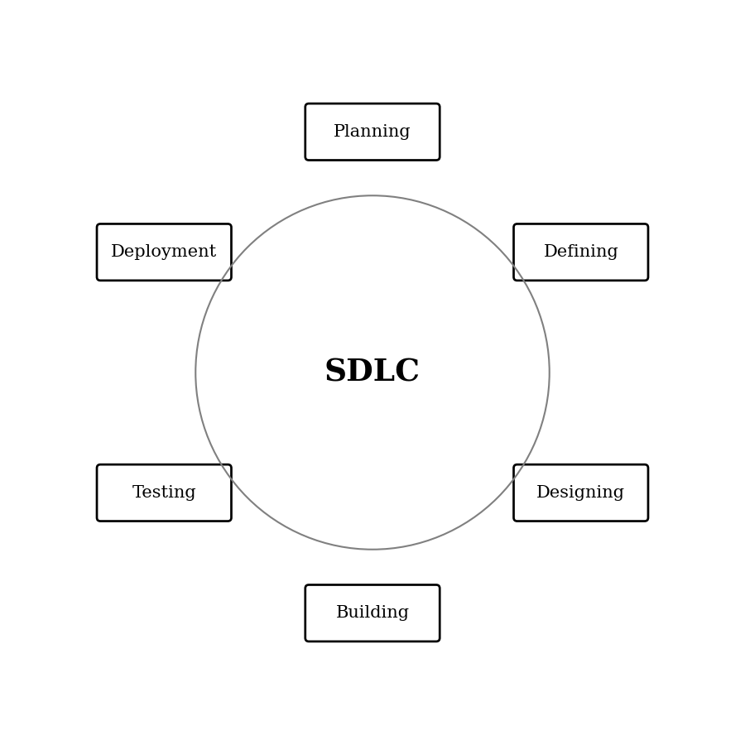
Figure: SDLC Stages

Stages of the SDLC applied to LLM-Prop

Stage 1: Planning and Requirement Analysis
Requirement analysis is the most important and fundamental stage in SDLC. For LLM-Prop this involved identifying the data sources (Materials Project), the conversion tool (Robocrystallographer), and the target material properties to be predicted, along with a feasibility study of the transformer-based approach.

Stage 2: Defining Requirements
Once requirement analysis was complete, the product requirements were documented in this SRS, covering the functional requirements (CIF conversion, preprocessing, model training, prediction) and nonfunctional requirements (performance, security, quality attributes).

Stage 3: Designing the Product Architecture
Based on the requirements in this SRS, the pipeline architecture was designed: CIF ingestion, text conversion, preprocessing and tokenization, transformer-based model training, and a CLI-based prediction interface. This design is captured in the UML diagrams in the following section.

Stage 4: Building or Developing the Product
In this stage, the actual implementation takes place using Python, PyTorch, and the HuggingFace Transformers library, following the architecture defined during the design stage.

Stage 5: Testing the Product
The system is tested against the requirements in this SRS, including validation of CIF parsing, correctness of generated text descriptions, and evaluation of prediction accuracy using Mean Absolute Error (MAE).

Stage 6: Deployment and Maintenance
Once tested, the system is made available to student researchers, materials science researchers, and developers as described in Section 2.3. Maintenance includes retraining the model as new datasets become available and extending the CLI toward the web-based interface noted in Section 6.

An Overview of UML
Unified Modeling Language (UML) is a general purpose modelling language. The main aim of UML is to define a standard way to visualize the way a system has been designed. It is quite similar to blueprints used in other fields of engineering.
UML is not a programming language, it is rather a visual language. We use UML diagrams to portray the behavior and structure of a system. UML helps software engineers, project evaluators, and researchers with modelling, design, and analysis of the LLM-Prop system.

Diagrams Used in This Document
The following UML diagrams are used to model LLM-Prop:
- Use Case Diagram – depicts the functionality of the system and its interaction with the Researcher, Developer, and external tools.
- Sequence Diagram – depicts the sequence of messages exchanged when a property prediction is made.
- Collaboration Diagram – depicts the structural organization of the objects involved in a prediction request.
- Class Diagram – depicts the static structure of the system's classes, their attributes, methods, and relationships.
- State Chart Diagram – depicts the state changes of a prediction request as it moves through the system.
- Activity Diagram – depicts the flow of control from input to predicted output.
- Package Diagram – depicts how the system's modules are organized and how they depend on one another.
- Component Diagram – depicts the implementation-level components of the system.
- Deployment Diagram – depicts the physical nodes on which the system executes.

Use Case Diagram
The use case diagram below shows the Researcher and Developer actors interacting with the LLM-Prop system, along with the external tools Robocrystallographer and the Materials Project API.
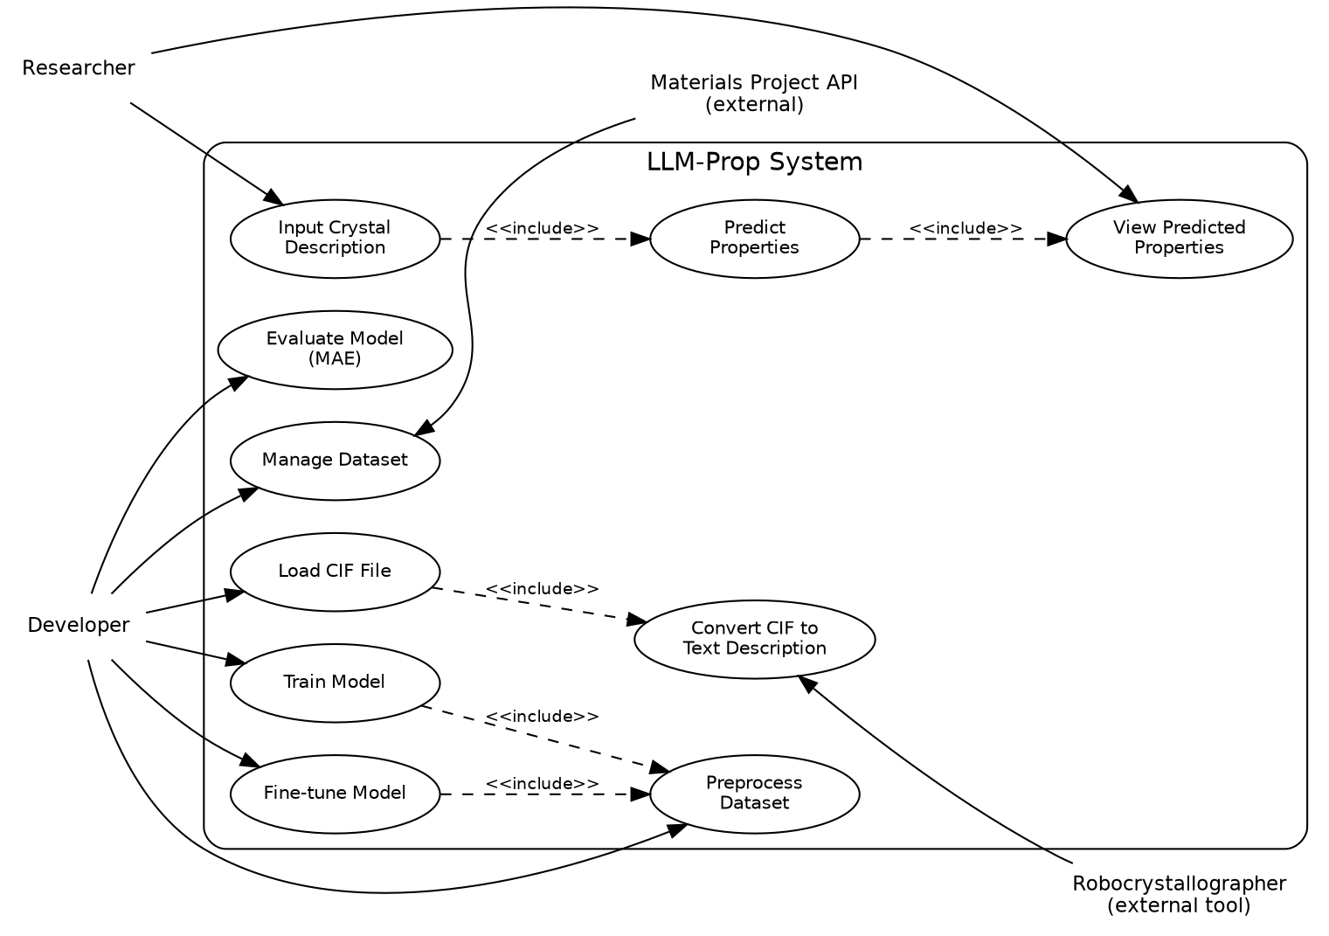
Figure: Use Case Diagram

Sequence Diagram
The sequence diagram below shows the order of messages exchanged between the User, the CLI Application, the Preprocessor, and the PredictionModel during a property prediction request.
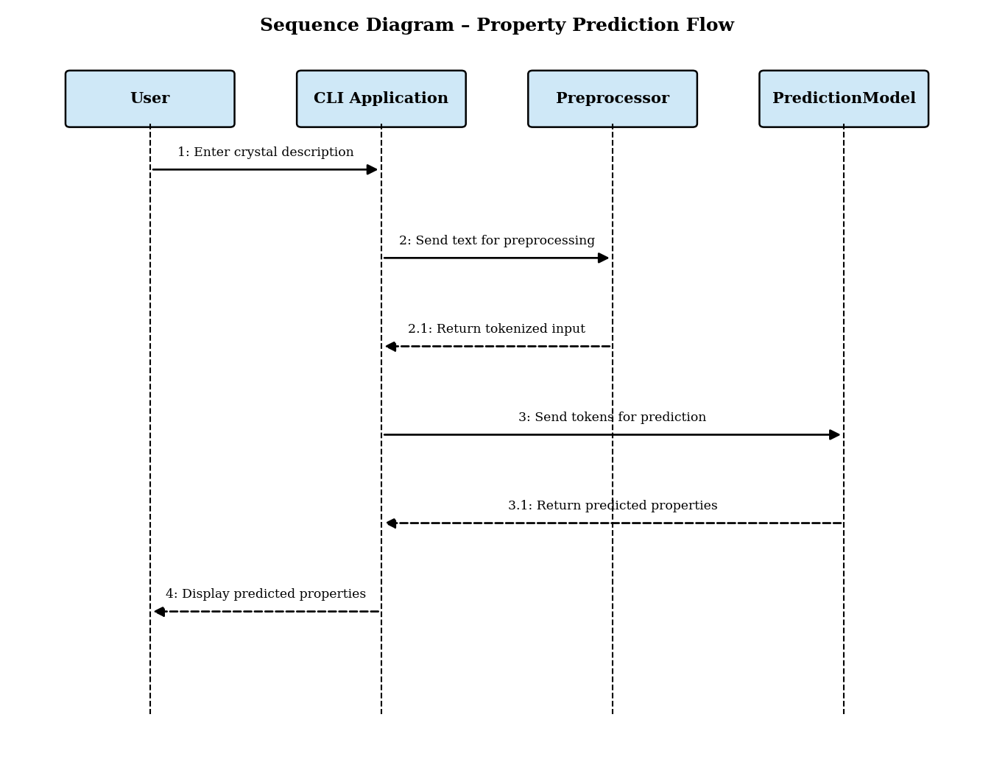
Figure: Sequence Diagram – Property Prediction Flow

Collaboration Diagram
The collaboration diagram below represents the same interaction as the sequence diagram, focusing instead on the structural links between the objects and the numbered messages exchanged between them.
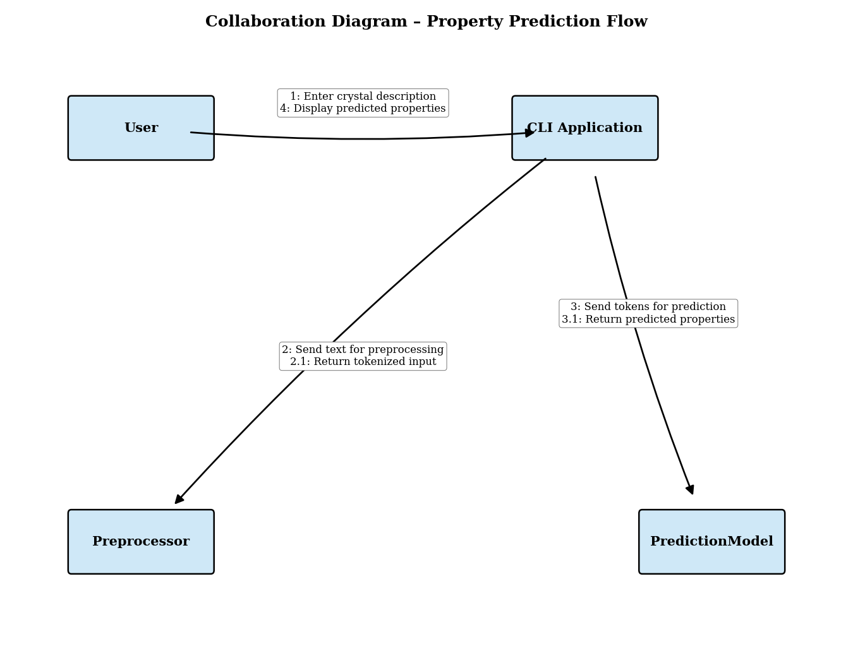
Figure: Collaboration Diagram – Property Prediction Flow

Class Diagram
The class diagram below shows the primary classes of LLM-Prop – CIFFile, TextDescription, Tokenizer, Dataset, PredictionModel, Prediction, Evaluator, and CLIInterface – along with their attributes, methods, and relationships.
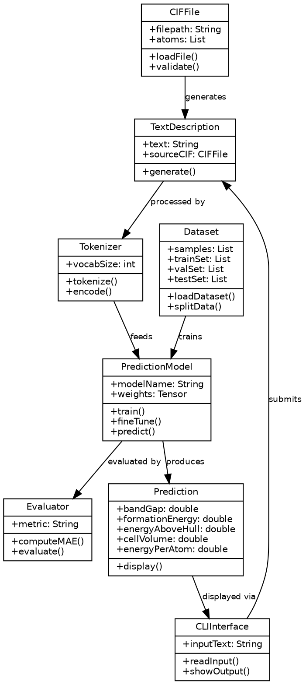
Figure: Class Diagram

State Chart Diagram
The state chart diagram below shows how a prediction request moves through the states Idle, Input Received, Validating, Preprocessing, Predicting, Completed, and Error.
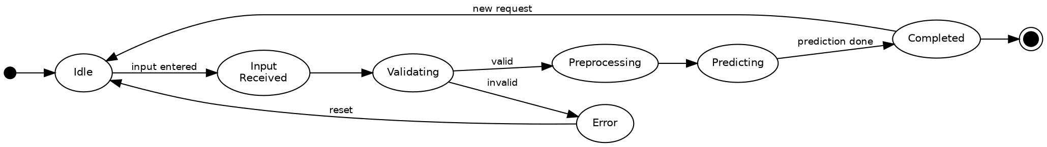
Figure: State Chart Diagram

Activity Diagram
The activity diagram below describes the flow of control from entering a CIF file or crystal description through to displaying the predicted properties, including the error path for invalid input.
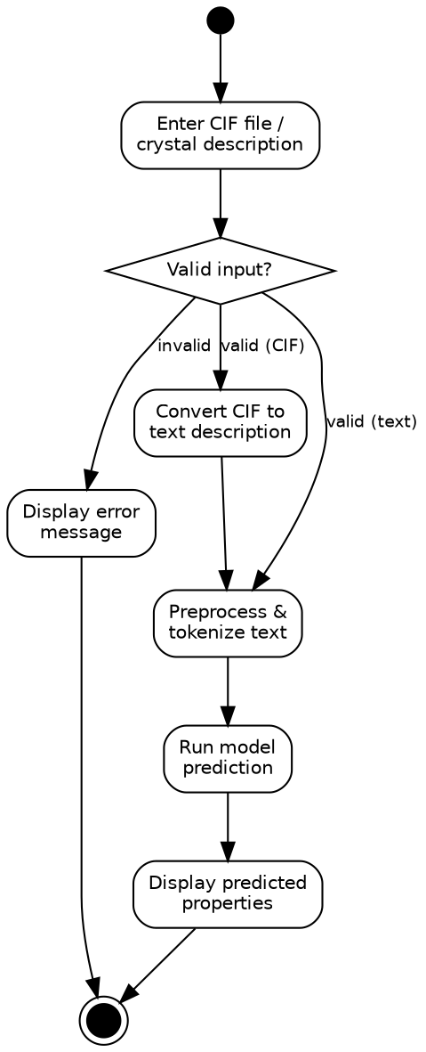
Figure: Activity Diagram

Package Diagram
The package diagram below shows how LLM-Prop's modules – Data Ingestion, Text Conversion, Preprocessing & Tokenization, Model Training, CLI Interface, Prediction Engine, and Evaluation – depend on one another.
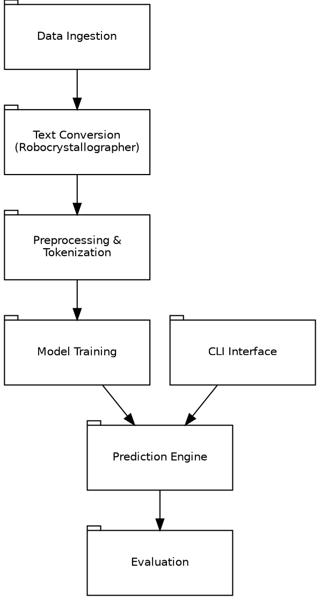
Figure: Package Diagram

Component Diagram
The component diagram below shows the implementation-level components of LLM-Prop and their dependencies, from the Materials Project Connector through to the Evaluation Component.
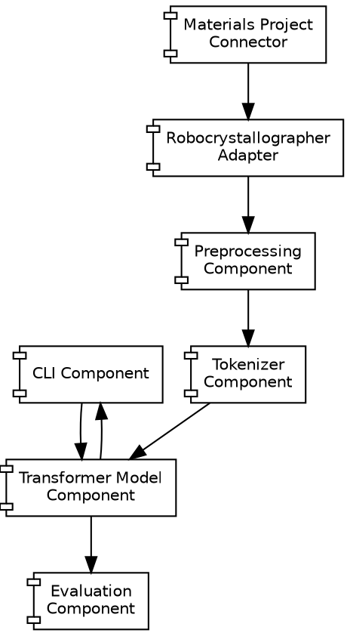
Figure: Component Diagram

Deployment Diagram
The deployment diagram below shows the physical nodes on which LLM-Prop executes: the user's machine running the CLI client, the compute node performing training and inference, local model storage, and the external Materials Project server.
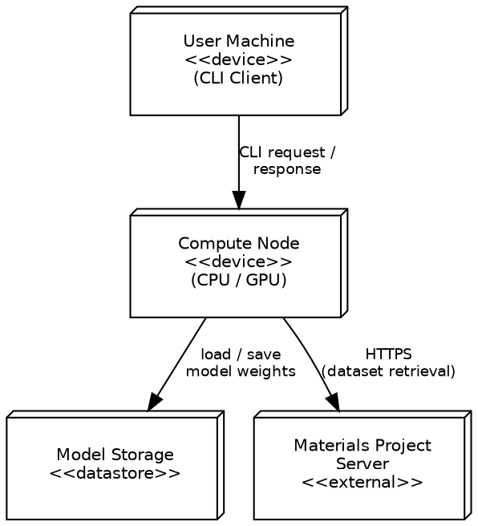
Figure: Deployment Diagram

